Christopher Guay

EDSGN 420

HW1: Imclose and Imopen

Objective: to explore and experiment with the properties and characteristics of the MatLab IMopen and IMclose functions in combination with a structuring element function.

Code:

im = imread('Image1.bmp');

im = imread('C:\Users\Christopher Guay\Documents\school\PSU Spring 2020\EDSGN 420\Image1.bmp');

size(im);

se=strel('disk',5);

imopen(im, se);

open1 = imopen(im, se);

close1 = imclose(im, se);

im:

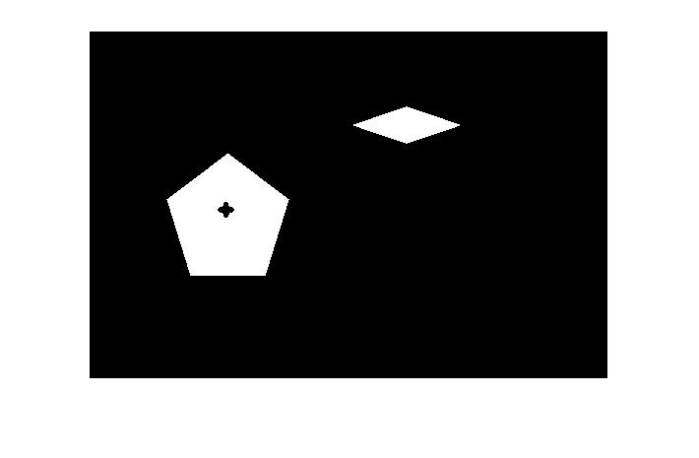

Open1:

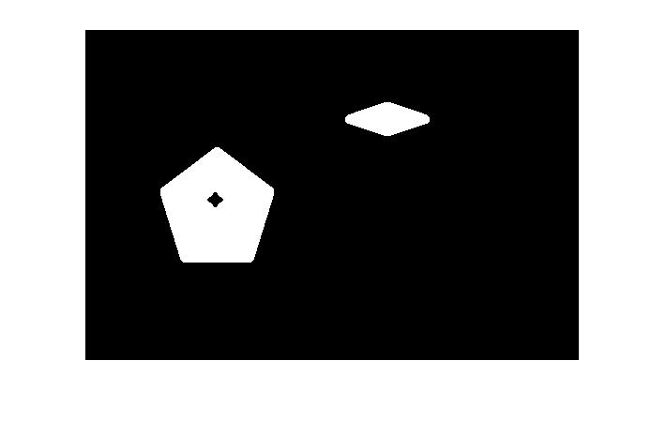

Close1:

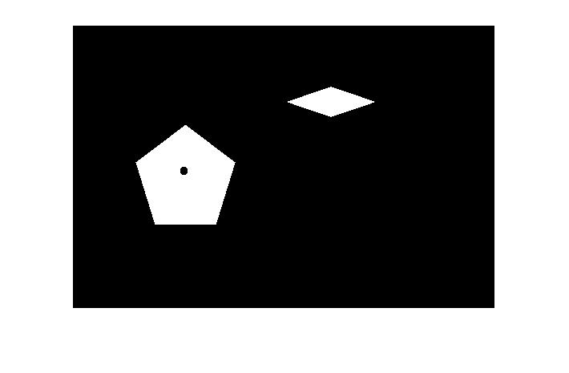

Conclusion:

The IMopen and IMclose functions were implemented successfully on the parent image “im”, where Open1 is the result of the call of the IMopen function on the im image. Close1 is the same, but with the IMclose function instead. You can see Open1 is similar to im but the internal of the shape edges are rounded off, as the structuring element has trouble reaching inside corners. Close1 shows an exactly opposite result, where the corners of the outside of shapes are rounded off, like the central star on Close1 which is not the same 4-pointed star that’s shown in im.